PUBLIC WATER SUPPLY DISTRICT #13

Minutes of the July 10, 2013

Regular Session of the Board of Trustees

The Board of Directors of Public Water District #13, Jefferson County Missouri met in regular session at 7:00 p.m. on July 10, 2013 at 5706 N. Lakeshore Dr., Hillsboro, Missouri.

Roll Call of Directors
The following Directors being present or absent as indicated:
Name Present/Absent
Marilyn Meyer Present
Rich Hirsch Present
Rick Lippitt Present
Ken Jost Arrived at 7:15
John Johnston Present
Also in attendance was Janet Hirsch (JWH, PWSD #13 bank administrator) and Frances Hovis (FH, Treasurer).

Approval of Agenda
Motion was made by Rick Lippitt and seconded by Rich Hirsch to accept the agenda. On voice vote, all Directors present were in favor of accepting the agenda.

Approval of Minutes of Past Meetings
The regular session Minutes of the June 12, 2013 meeting were emailed to the Directors prior to the meeting. Motion was made by Rick Lippitt to approve the regular session Minutes as written. Second was by John Johnston. On voice vote, the regular session Minutes were approved.

Treasurer’s Report
FH reported the balances for May 30: O&M checking acct: $70,201.50; O&M money market acct: $251,452.82; debt service reserve acct: current balance not received by meeting time.

Delinquent payment issues
Summary of amounts owed to the District by homeowners that have liens against their property:

Name | Total owed on 06/30 |  | Name | Total owed on 06/30
DL | $1376.60 |  | JM | 305.60
JK | 1304.80 |  | KS | 705.60

JM did send the district $400, as promised. KS said he would send in what he owes at the end of July. DL and JK houses are abandoned.

Invoice approval
The following payment requests were submitted for Board approval in July.
Payee | Invoice amt
WRM, WWPT Operator | $1,075.00
Bookkeeping services | 495.00
Ameren Missouri for TP (paid, DirectPay) | 261.46
JWH, postage, monthly billing | 74.58
Sewer user fee for office | 72.00
Ameren Missouri for Sewer Office | 15.01
AT&T (paid, preapproved) | 41.44
Grass cutting | 140.00
Repair sewer line break @ 5996 N LSD, day 1 | 1,055.00 ª
Repair sewer line break @ 5996 N LSD, day 2 | 1,805.82 ª
Repair sewer line break @ 5996 N LSD, parts | 231.98 ª
Grass cutting, along Telle property | 250.00 ^{b}
Thermostat for sewer office | 21.55
PVC pipe fittings | 15.90
Screws for WWTP filter handles | 4.04
Missouri One Call | 10.40
TOTAL | $5,569.18
a) Total $3092.80 for crushed cleanout.. See report under Collection System Operation.
b) Removed grass, brush, small trees between creek and western property line.

Motion was made by Rick Lippitt to approve payment of the invoices. Second was by Rich Hirsch. On voice vote, payment was approved.

June Cash Flow Report
JWH handed out the cash flow report for June, 2013 prepared by the bookkeeper and required by our lender USDA-RD. Sewer fees invoiced were $17,350.53; sewer fees received were $17,531.68; cash inflow was $17,628.09; Cash outflow was $10,713.76; net cash flow for the month was $6,914.33. The June cash report is in Appendix A.

Old Business
Warranty Issues
RH reported on the June 19 warranty issue meeting with TGB (Sharon Tielke), Tim Robbs (Taylor Eng.), and Donna Martin (USDA-RD). A summary of the meeting results was written by JWH and is in Appendix B.
Orenco offered to pay $20 per float to install plus a replacement float. The board considered this generous since the Orenco warranty only covers materials and not the labor to install. TGB world not install the floats for $20/float. Sharon (TGB) wrote: "Float issue is not a TGB item but, Orenco or Flo-Systems may pay us to install while we are performing the three items above." Steve (TGB) wrote: "We have to pay our guys prevailing wages and the $20 does not cover the removal and replacement of the float. We will be happy to coordinate the opening and closing of the septic tank/splice box with someone else who will replace the floats concurrently with us."
There was a discussion of whether just replacing the ALARM float was sufficient, or if the PUMP ON and PUMP OFF floats would also need to be replaced, since those floats have a water-permeable insulation problem also. The board decided to only change the ALARM floats, since the PUMP ON and PUMP OFF floats actuate a relay, while the ALARM float triggers the alarm light and buzzer directly.
Dave Axton agreed to have his agent (Dale) change floats for $20/float. This was agreeable to the board since Dave (Dale) could follow TGB and check their work.
Missing pump at 5953 S LSD is not in the trailer, but we do have three new pumps at the TP.
The board agreed that we should have Tim Robbs put the main SOVs on the as-built plans. The plans are incomplete as they now stand.
For Ferrell at 5828 N LSD, Tim Robbs said that riser is strong enough for driving on, just replace the lid with an unbreakable metal lid.

MO1Call activity
RL reported four calls since the last meeting from the cable company.

Grass cutting
Grass cutting looks good.

Treatment plant operation update
RH summarized the Bids:
1) Chad Queen: $12,000 - $17,000
2) Gateway Mechanicals: $9,658.00
3) Pete Bossert Contracting, LLC: $7,200.00
The proposals were discussed. Motion made by RH to accept the bid submitted by Pete Bossert. Second was by RL. On voice vote the motion was approved.
Bid details: The price for relocating the flow meter to the new proposed location without a concrete base will be $5,700.00. To add a concrete base under the new riser, cost would be $1,500 more. The concrete pad would be 4'x4', 8" thick with re enforcing steel. (Revised to 7'x7', 12" pad rebar (#4) on 12" centers like Taylor Eng drawing).
A 1" pvc conduit with pull string would be installed from the metering base to the new flow meter, and the owner would be responsible for supplying and installing the metering cable. (Revised to 1-1/2" or 2" pvc conduit with a pull wire at no additional cost).
Contractor will leave existing riser and lid for future access. Installing a spool or a flanged jumper to replace the meter is included.
None of the bids included running cables to the new meter. The Bossert bid included installing PVC conduit with a pull string. We will have to get bids for running the cabling to the meters.

Collection system operation update
Three cleanouts were damaged in June 2013:
1) Thursday, June 13: Grandchild of owner of 5981 S LSD ran over a 2" cleanout (CO) with a lawn mower and destroyed the top of the CO. RL handled this problem.
RL determined what was needed to repair the CO and also, that we did not have those parts on-site. Son of owner repaired the CO with parts purchased from Lowes that day.
Late June 13 RH looked at the repair and approved. There was some sewage discharge still present based on smell. The discharge probably occurred when the lawn mower destroyed the CO.
When RH looked at the CO on June 17, the CO had dirt pushed up against it and satisfactory.
2) Tuesday, June 18, 2013: A truck probably ran over the 3" CO and broke the PVC Tee fitting where it connected to the main sewer line. Repair is described in Appendix C. Cost was $3,092.80.
3) Tuesday, June 25, 2013: Grass cutter employed by LTPOA ran over a 2" CO pipe. Pipe was cut off square and clean by cutter. RH got PVC glue, replacement collar, and plug from TP. RH installed the collar and plug and stopped the fluid flow.
The board agreed that all COs close to the road should be protected, possibly in a manner described in Appendix C. SOVs are less of a problem because they are in a pit.

Operator report
RH described a high level problem where the pump was not pumping. See Appendix D.

Adjournment
There being no other formal business to come before the Board, a motion to adjourn was made by Rick Lippitt and seconded by Ken Jost. Motion passed. Meeting ended at 8:30 p.m.

Respectfully Submitted,

Rich Hirsch
Recording Secretary

Approved this 14th day of August, 2013.

___________________________ _________________________________
Secretary Chairman
August 9, 2013

APPENDIX A. June 2013 Cash Report
Sewer Fees Invoiced | $ 17,350.53
Sewer Fees Received | $ 17,531.68
Overdue Amounts:
30 days overdue | $ 1,627.85
60 days overdue | $ 1/083.92
90 days overdue | $ 607.44
Cash Inflow
Sewer User Fees | $ 17,531.68
Interest | 96.41*
 | 17,628.09
Cash Outflow
Accounting | 407.00
Treatment Plant Operator | 1,640.00
Utilities - electric (treatment plant) | 277.32
Utilities - electric (office) | 17.34
Phone | 41.38
Sewer fee - office | 72.00
Missouri One Call - locate fee | 3.90
Dale Wallen - grass cutting | 140.00
USDA Interest | 6,980.00
Debt Service Account | 962.00
Maintenance/replacement (PVC primer and cement) | 10.58
Customer Refund of overpayment (Furrer) | 73.00
Postage & printing | 75.24
Bank Fees (ACH debit & overdraft) | 14.00
 | 10,713.76
Net Cash Flow | $ 6,914.33

* Have not yet received Bank Statement for Debt Service Acct.
Interest is approximately $2.50/month - not included in interest shown.

APPENDIX B. Warranty Issues, Meeting 6/19/2013
Warranty Issue | Result | TGB's Response
1) Lateral line break at 5840 N LSD on Apr 22, 2013. Repaired by Pete Bossert on Apr 23. Cost was $660. District wants reimbursement. | TGB will send check for $660 to PWSD#13 for reimbursement. | $660 reimbursement to board along with #4
2) Due to defects in the installation of conduit sealant OR improper bedding-in of the tank, the district is plagued with low volume audible alarm problems. Approximately 11% of the installations have had these problems as of May 1. Water enters the wiring splice box (SB) and causes a partial short that triggers the high level alarm buzzer. The district wants to be compensated for the extra trips our operator has had to make to correct these problems. So far 20 to 25 installations have had to be repaired. Each time Dave makes a service call, we have to pay him $60.  It is Dave's opinion that ALL 238 installations will eventually get flooded splice boxes. We are asking for $60 for each failed SB we have found.  We are also asking TGB to visit every SB that they installed and make a repair so that the SB will never again fill with water. The repair method is to be specified by the design engineer and Orenco. | The weak volume audible alarm can be caused by water in the splice box, bad wires on the alarm level floats, or both.  Orenco will provide 238 new floats.  TGB will visit all 238 installations and at each will  - Dry the splice box  - Install the new float  - Install new waterproof wire nuts where needed  - Foam the conduit at the splice box  and conduit at the control panel. An approved sealing foam will be used.  They will do one installation and upon approval, will do the rest. PWSD#13 will spot check the installations. | I am getting a proposal to install expandable foam at a) splice box and b) control panel and c) install waterproof wire nuts on the ground connections (or any other connection in SB -- rhh) – otherwise TGB forces will complete these three items – our goal is to have a start date determined (or start) this week.  Float issue is not a TGB item but Orenco or Flo-Systems may pay us to install while we are performing the three items above.
3) The unoccupied house at 5953 S LSD is missing a pump and discharge assembly.  District would like TGB to install the missing equipment. | TGB does not have the pump and assembly. 238 pumps were delivered and accepted by the inspector. RH will look in the TP trailer for the missing pump. | removed from list
4) Slow but significant leaks in the main sewer line or lateral line have been found at the street SOV at 6097 S LSD and 5748 S LSD. Both pits contain black water that smells like sewage. The pit at 6097 tested positive for coliform. On 6/1 both pits were drained and treated with household bleach to kill active bacteria. On 6/10 both pits were checked and found once again to contain black water that smells like sewage. District wants both leaks repaired. | PWSD#13 will ask contractor Bossert for estimates to repair. TGB will either accept the bid and pay for it, or perform the work themselves. | awaiting price to repair from board’s contact
5) One ARV near 6259 S LSD has a slow drip-drip leak of sewage from the upper vent of the valve body. District wants leak fixed or ARV replaced. | Dan Hufker (Orenco) advised Tim that there may not be enough pressure on the ARV. It was suggested that we operate the ARV as a manual Air Release Valve and schedule occasional bleeding. | removed from list
6) CP1 at the TP never indicates a high level alarm, because no float is hooked to the intrinsically safe relay (ISR). District would like the circuit completed or modified so that CP1, CP2 & CP3 ALL show high level alarms when there is high water. | TGB will consult with Flo-Systems and between them, they will rewire CP1 so the high level alarm will operate as CP2 and CP3. | removed from list
7) Deeply buried STEP tanks that are very difficult to service were found at 6383 S LSD (filter, SOV, splice box,) and 5840 N LSD (filter, SOV). District would like filter holder extensions and any other helper aids. | TGB will fix these. | extension will be added while working on items listed in #2
8) Homeowner at 6013 N LSD believes TGB installed the wrong type of cleanout (CO). He insists that TGB should have installed a "rodding tee" instead of a Wye. That way he could snake out a clog in the upstream or downstream direction. This is currently not the case. He wants the error corrected.  What was the basis for NOT installing a rodding tee? Homeowner had to remove the toilet to snake out a clog. District wants an explanation as to why Wye is better or CO replaced. | TGB will provide a statement explaining the installation of the tee.  PWSD#13 will forward the statement to the customer. | should have email response this week
9) As-built plans don’t show all valves. Dave has found 2 ARVs that are NOT on the as-built plans: ARV-N-11 at 6084 N LSD and ARV-N-12 at 6020 N LSD. One ARV on the as-built plans does not exist: ARV-S-12 at 6051 S LSD. District wants plans corrected. | PWSD#13 will provide the location information and Taylor Eng. will correct the as-built plans. | removed from list
10) A. Ferrell, 5828 N LSD: Mr. Ferrell is unable to use his parking area because of an ill-placed ARV pit. He wants current breakable lid replaced with a drivable traffic lid. Al Ferrell: (636) 274-xxxx | Tim advised that the ARV could be turned off permanently and a unbreakable (metal) lid installed on the existing riser.  PWSD#13 will investigate obtaining a new lid. Riser may need to be lowered (cut off) so lid is at grade level. | removed from list
11) Landscape issues:  a) A. Toscano: Installation of neighboring tanks removed rock from his driveway: Homeowner wants his 9'x120' driveway re-rocked. Sample rocks in Sewer Office. Alfio Toscano: (636) 274-xxxx  b) M. Holland: Hollands are still not satisfied that lakeside ground has been returned to pre-construction condition -- too many rocks. | TGB will speak to both customers. | Holland– we will make offer while on site working on items listed in #2  Toscano – rocks were added last year – board agreed not a warranty issue (?? -- rhh) – we will confirm while on site working on items listed in #2
12) Reneski, 5765 N LSD: Splice box in tank is hanging by the wires. Tank lid was broken and had never been attached (no holes in riser). RH screwed down new lid on 6/17/2013. District wants splice box repaired. | TGB will repair. | repair will be made while working on items listed in #2
13) Hirsch, 6089 S LSD and other locations: Non-waterproof wire nut used for ground connection. RH has seen this in other SBs also. District wants these wire nuts replaced with waterproof wire nuts when conduit sealer is applied. | TGB will replace any non-waterproof wire nuts with waterproof wire nuts in the tank slice boxes. This will be done when conduit sealant is being applied. | see #2 response
Summary by J Hirsch, June 21, 2013
APPENDIX C. Repair of Cleanout Break at 5996 N LSD

Leak reported on Tuesday, June 18, 2013 probably due to truck running over CO.

June 19: Pete Bossert Contracting arrived about 1300. From Pete's invoice:
"Received call for broken sewer line @5996 lakeshore dr. Dug up break to discover pipe next to clean-out "Y" broken. Called six supply stores could not find parts needed in stock. Ordered parts and temporarily patched broken line with rubber and clamp. Parts came in following week."
June 26: "Returned to complete repair with ordered parts. Dug up broken pipe, shut off main upstream, downstream, shut off houses in-between, made repair. Turned valves back on. Backfilled with clean rock, set cast iron cleanout access cover in 4 bags concrete."

On June 26 RH got to site at 1015. At that point hole was uncovered and cracked Wye was exposed. Four guys were working. When I got there all SOVs between main line SOVs had been closed off. Main line SOVs are at 5876 N LSD and 6020 N LSD. According to as-built plans, there are 13 houses between main line SOVs.

Repair was finished by adding an extra 6" diameter pipe placed around 3" pipe to protect. Used 4 bags of ready-mix and cast iron lid.

Sawzall was used to remove damaged Wye fitting. New Flanged joint fit due to limited space

Total cost: $1055.00 + $1805.82 + $231.98 = $3,092.80

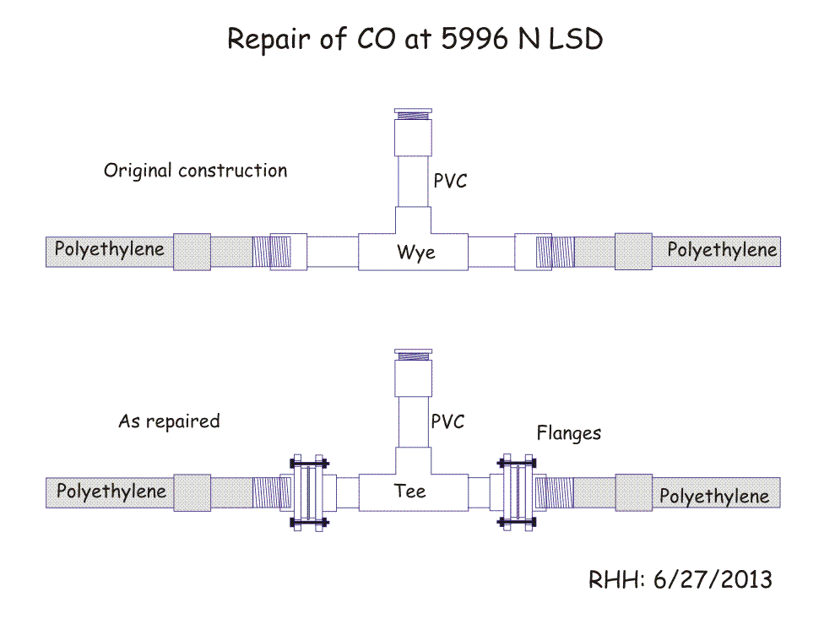
APPENDIX D. High Level Problem: Pump not Pumping

Dave stopped by on July 4 to inform me of an unresolved problem at 7796 Mohawk Tr. Dave was called after the homeowner heard a high level alarm. The tank indeed was full. Dave pumped it down and did the usual troubleshooting and determined that the contactor (motor relay) in the control panel was fused and inoperable.
On July 5 RH met Dale K. at 7796 Mohawk at 0730 to get the system working again. After replacing the contactor, when the main switch was set to "Manual" the contactor chattered badly (rapidly switched on/off, repeatedly). Replacing the existing pump with a new pump did not help any.
At this point we directly wired the new pump to the homeowner's disconnect with an extension cord. The pump drew close to 20 amps but did not come on. When I measured the voltage across the pump leads, it was less than 40v, which is not enough to start the pump motor. [When RH tested the pump at his home plugged into an ordinary outlet, it started right up. It initially drew ~20a, but quickly settled down to 8.6a (spec is 10a) at 114v.]
So what was happening, was that the pump was drawing 20 amps current, but the supplied voltage was insufficient to start the pump turning. (The instantaneous starting current of the pump should be about 20a, but once the pump starts the operating current should drop to about 10a.)
When the pump was wired through the contactor, the voltage applied to the contactor was enough to close the contactor, but when the contactor closed the voltage dropped to < 40v, which caused the contactor to open. The result was a contactor that chattered. Excessive current draw with low voltage also explains the original fused contactor. The relay contacts became so hot that they melted the surrounding plastic of the contactor and caused it to fuse.

Enlightenment
We noticed that the voltage at the disconnect was 135v, rather than the expected. 120v. RH measured another outlet at 105v. So while the total was ok (135 + 105 = 240v), each leg was off by 15v. The homeowner also said his lights were flickering. Both are symptoms of a "neutral problem" either at the pole (AUE's responsibility) or in the homeowner's electrical panel (homeowner's responsibility).
So we got the homeowner to call AUE to check the line to the house. Within a half hour an AUE truck arrived and as we were leaving, the tech started working.
On Saturday Dale K. went back to 7796 Mohawk. When he checked the voltage, it was 120v both before and after the pump started running. The system was set to "AUTO" and was operating as designed. -- RH

P.S.
1) One doc from Orenco "Control Panel Troubleshooting" ECH-CP-1 says that if "the motor contactor is chattering" check:

• Inadequate voltage being supplied.
• A single "A" float is being used to turn the pump on/off.
• Bad failed float (ON or OFF float)
• Corroded contacts.

We did have corroded contacts in the old contactor. And we do have inadequate voltage being supplied.
2) Elapsed time meter had 149 hrs on it, but the meter may have continued to run even though the pump was off.

